**Lab Program Number: 4 Date: 2082-03-17**

**Title: Static IP Setting on Windows/Linux Machine using GUI and Command Prompt**

**THEORY**

1. **IP Address**

An **IP address (Internet Protocol address)** is a unique string of numbers separated by periods (IPv4) or colons (IPv6) that identifies each device connected to a network, such as the internet. It acts like a **home address** for devices, allowing them to send and receive data from other devices.

**Example of an IP Address:**

IPv4: 192.168.1.1

IPv6: 2001:0db8:85a3:0000:0000:8a2e: 0370:7334

1. **Static IP address**

A static IP address is an IP address that is manually assigned to a device and remains fixed over time. It does not change each time the device connects to the network. Static IP addresses are often used for servers, websites, and devices that require constant access, such as CCTV systems or remote desktop connections.

**Example:**

A company’s web server might use a static IP like 203.123.45.10.

1. **Dynamic IP Address**

A dynamic IP address is automatically assigned to a device by a network service called DHCP (Dynamic Host Configuration Protocol). These IP addresses can change over time, especially when the device disconnects and reconnects to the network or restarts.

**Example:**

When our phone connects to Wi-Fi, it might be assigned an IP like 192.168.0.10, which could change the next time it connects.

1. **Subnet Mask**

A Subnet Mask is a number that defines the range of IP addresses that can be used within a network. It divides an IP address into two parts: the network portion and the host portion. This helps devices determine whether another device is on the same local network or not.

**Example:**  
IP: 192.168.1.10

Subnet Mask: 255.255.255.0

Device from 192.168.1.10 to 192.168.1.254 are on same network

Bottom of Form

1. **Default Gateway**

A Default Gateway is a device, typically a router, that connects a local network to other networks, including the internet. It acts as an access point through which data is sent when the destination IP address is outside the local network.

**Example:**  
If our computer’s default gateway is set to 192.168.1.1, then our device sends internet requests to it for forwarding.

1. **DNS Server**

A DNS Server (Domain Name System Server) is responsible for translating domain names (such as www.google.com) into IP addresses (like 142.250.190.36). Since computers use IP addresses to identify each other on the network, the DNS server makes it easier for humans to access websites using readable names.

**Example:**  
When we type [www.google.com](http://www.google.com), DNS changes it to 142.250.190.36 so our browser can load it.

**Network Information**

Fig: Default network Information

Checking network connectivity on default network connection using ‘ping’ command to test connectivity with the gateway and external sites.

Fig: Network connectivity

1. **Static IP Configuration on a Windows Machine using GUI**

**Step 1: Open Network and Sharing Center:**

Open the Control Panel from the Start menu, then go to Network and Internet then click Network and Sharing Center.

Fig: Network and sharing center in control panel

**Step 2: Access Adapter Settings**

* 1. In the left pane, select Change adapter settings.
  2. Right-click the network connection you want and choose Properties.

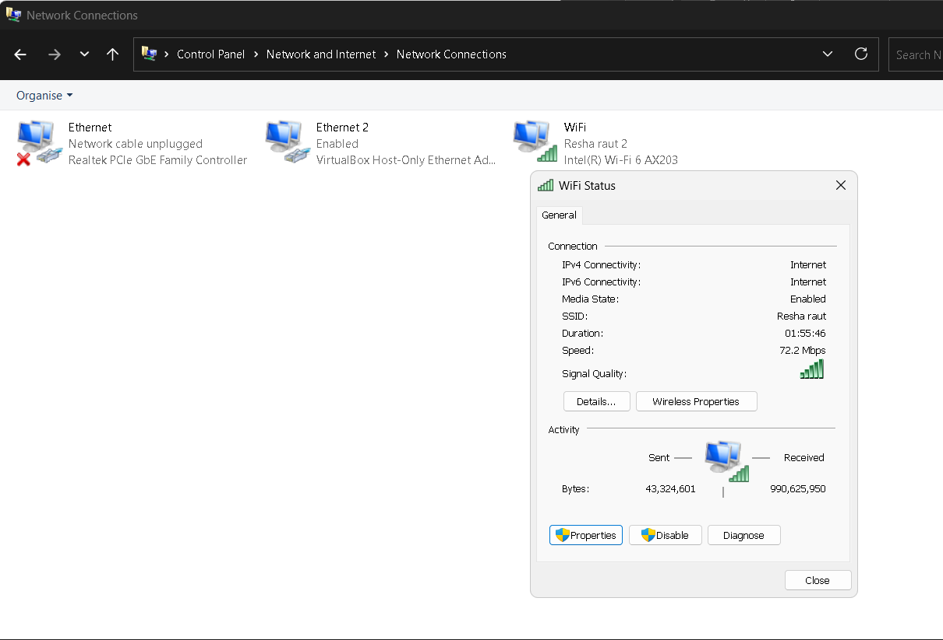

Fig: Network selection on Adapter Settings

**Step 3: Configure IPv4 Settings**

* 1. Click on Internet Protocol Version 4 (TCP/IPv4), then select Properties.
  2. Choose “Use the following IP address” and enter:

IP: 192.168.1.150

Subnet Mask: 255.255.255.0

Default Gateway: 192.168.1.254

Set the DNS to:

Preferred DNS: 8.8.8.8

Alternate DNS: 1.1.1.1

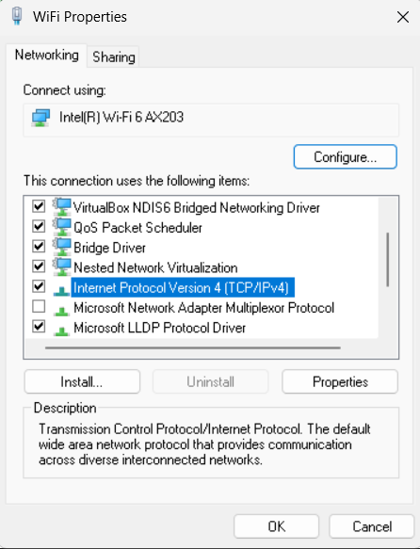

Fig: Selecting IPv4 for configuration

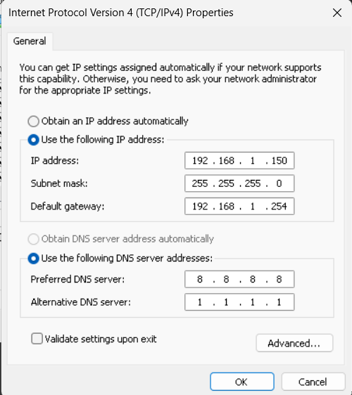

Fig: Configuring IPv4 address

**Step 4: Save and Verify**

* 1. Click OK to save and apply the changes.
  2. Open Command Prompt and run the ipconfig command to check if the static IP is set correctly.

1. A computer screen with white text

   AI-generated content may be incorrect.Fig: Default network information after Static IP configuration

Verifying network connection after setting a static IP by using the ping command

to test access to the gateway and external servers.

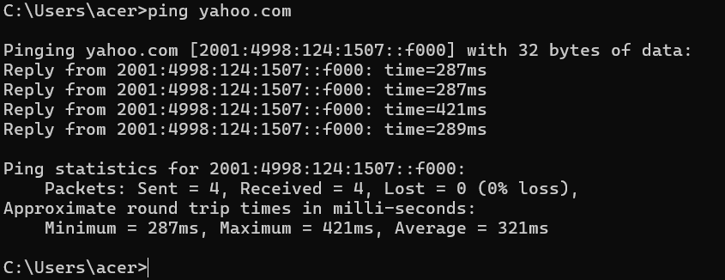Fig: Network connectivity of Yahoo server

1. **Static IP configuration Using Command Prompt (CLI)**

**Step 1: Check the Device’s Current Network Status**

The current settings show DNS:

IPv4 address as 192.168.1.76,

Subnet Mask as 255.255.255.0

Default Gateway as 192.168.1.254

Fig: Default Network Information

Checking Network connectivity using ping

Fig: Network connectivity of Facebook server

**Step 2: Get Network Interface Name**

***Syntax****:* *netsh interface ipv4 show interfaces*

**Step 3: Set Static IP**

***Syntax****:* *netsh interface ip set address name=”WiFi” static 192.168.1.150 255.255.255.0 192.168.1.254*



Fig: Setting Wireless LAN Static IP

**Step 4: Set DNS Servers**

***Syntax:*** *netsh interface ip set dns name=”WiFi” static 8.8.8.8*

***Syntax:*** *netsh interface ip add dns name=”WiFi” 1.1.1.1 index=2*

Fig: Setting DNS

**Step 5: Verifying Configuration:**

After configuring the Static IP using Command Line Interface (CLI) with the commands above, the IPv4 address updates from 192.168.1.76 to 192.168.1.150, We can confirm this change using the following command.

***Syntax:*** *ipconfig/all*

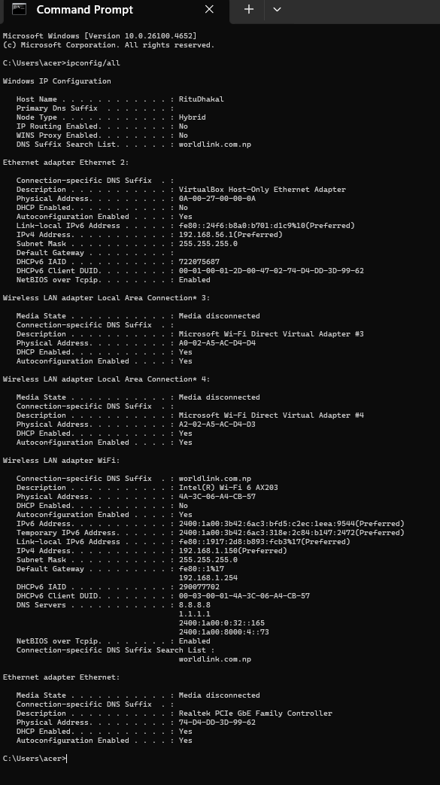

Fig: Verifying Configuration

Checking Network connectivity

Fig: Network connectivity of Deepseek

**Conclusion**

In this lab, we effectively configured static IP addresses on both Linux and Windows platforms. Assigning a fixed IP is essential for devices that need reliable and continuous network connectivity. Through the process of setting and verifying these configurations, we gained valuable insight into managing network settings. This practical exercise strengthened our technical skills and equipped us with the knowledge needed for handling real-world networking tasks, including troubleshooting and system optimization.